Introduction to Data Science

Data science is an interdisciplinary field that utilizes scientific methods, algorithms, processes, and systems to extract knowledge and insights from structured and unstructured data. It combines elements of statistics, mathematics, computer science, and domain-specific knowledge to uncover patterns, trends, and relationships within data.

Here's a breakdown of key components within data science:

**Data Collection:** Data scientists gather raw data from various sources such as databases, APIs, sensors, or manual data entry.

**Data Cleaning and Preprocessing:** Raw data often contains errors, inconsistencies, or missing values. Data scientists clean and preprocess the data to ensure its quality and suitability for analysis. This involves tasks like handling missing values, removing outliers, and standardizing formats.

**Exploratory Data Analysis (EDA):** EDA involves visualizing and summarizing data to understand its underlying structure, patterns, and relationships. Techniques like statistical analysis, data visualization, and dimensionality reduction are commonly used in this phase.

**Feature Engineering:** Feature engineering involves selecting, transforming, and creating new features (variables) from the raw data to improve the performance of machine learning models. This process requires domain knowledge and creativity.

**Model Building:** In this phase, data scientists select appropriate machine learning or statistical models to analyze the data and make predictions. Common techniques include regression, classification, clustering, and neural networks.

**Model Evaluation and Validation:** Once models are trained, they need to be evaluated to assess their performance and generalization ability. Techniques such as cross-validation and metrics like accuracy, precision, recall, and F1-score are used for evaluation.

**Deployment and Monitoring:** Successful models are deployed into production environments where they can be used to make predictions on new data. Continuous monitoring and maintenance are essential to ensure that deployed models remain accurate and relevant over time.

**Ethical Considerations:** Data scientists must consider the ethical implications of their work, including privacy, fairness, and bias. They should strive to develop models that are transparent, accountable, and respectful of individual rights.

Types of Data: structured and unstructured data

|  |
| --- |
|  |
|  |
|  |

**Work Of Data Scientist and Data Analyst?**

|  |
| --- |
|  |

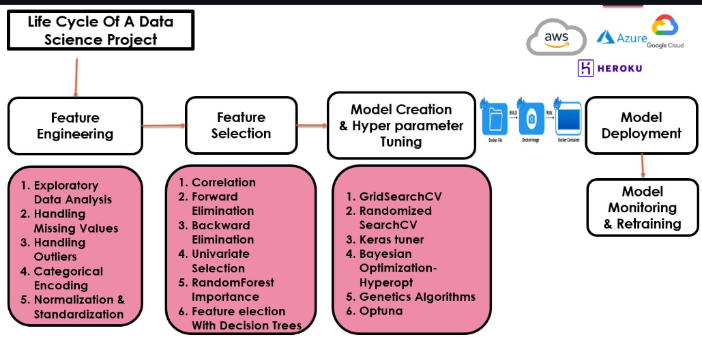

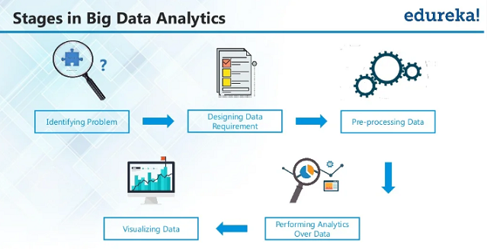

**Define the Problem:**

Clearly articulate the problem you want to solve or the question you want to answer through data analysis.

Understand the business or research objectives and how they relate to the problem.

**Data Collection:**

Gather relevant data from various sources such as databases, APIs, files, or external datasets.

Ensure the data is sufficient, accurate, and representative of the problem domain.

**Data Cleaning and Preprocessing:**

Handle missing values: Decide how to handle missing data points (imputation, deletion, etc.).

Remove duplicates: Identify and remove duplicate records from the dataset.

Standardize data formats: Convert data into a consistent format for easier analysis.

Normalize or scale data: Standardize the scale or distribution of numerical features if necessary.

Perform other preprocessing steps like encoding categorical variables or feature scaling.

**Exploratory Data Analysis (EDA):**

Summarize data: Compute descriptive statistics (mean, median, standard deviation, etc.) to understand the distribution of data.

Visualize data: Create visual representations (histograms, box plots, scatter plots, etc.) to explore relationships and patterns in the data.

**Identify correlations:** Analyze correlations between variables to uncover insights.

Perform feature engineering: Create new features or transform existing ones to improve model performance.

**Model Selection and Training:**

Select appropriate models based on the problem type (classification, regression, clustering, etc.) and data characteristics.

Split the dataset into training and testing sets for model evaluation.

Train machine learning models using algorithms such as linear regression, logistic regression, decision trees, random forests, support vector machines, or neural networks.

Optimize model hyperparameters using techniques like grid search or random search.

**Model Evaluation:**

Evaluate model performance using appropriate metrics (accuracy, precision, recall, F1-score, etc.) on the test dataset.

Compare multiple models to select the best-performing one.

Use techniques like cross-validation to assess model generalization ability and detect overfitting.

**Interpretation and Insights:**

Interpret model results and extract actionable insights.

Communicate findings effectively through reports, visualizations, or presentations.

Validate insights with stakeholders or domain experts to ensure relevance and accuracy.

**Deployment and Action:**

Implement recommendations or actions based on the insights derived from the analysis.

Monitor outcomes and performance to assess the effectiveness of implemented solutions.

Iterate on the deployment process as needed to optimize results over time.

**Documentation and Reproducibility:**

Document the entire data science process, including problem definition, data collection, preprocessing steps, modeling techniques, and results.

Ensure that the analysis is reproducible by providing code scripts, notebooks, or workflows that allow others to replicate the results.